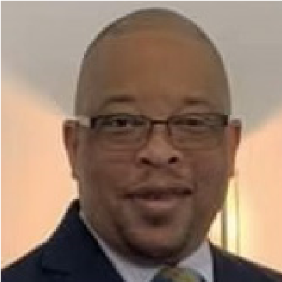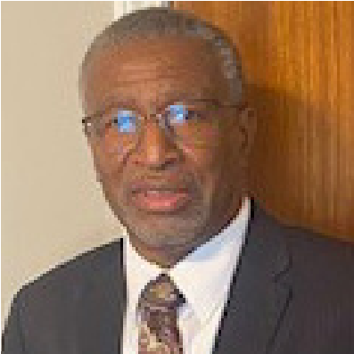

Rev. Dr. Timothy

A. Collazo,

Moderator

Pastor, Gordonsville Baptist Church

Hopkinsville, KY

Rev. Thomas Jones,

President Address

Tues. 7 PM

Rev. Jeremiah Jordan,

Sermon

Tues. 10 AM

Pastor, Hopewell Missionary Baptist Church

Glasgow, KY

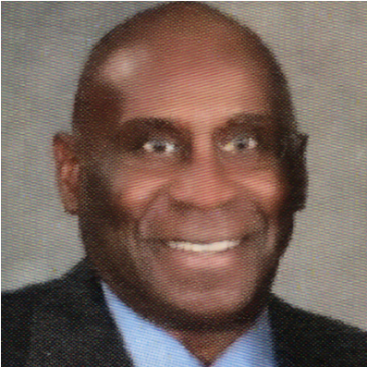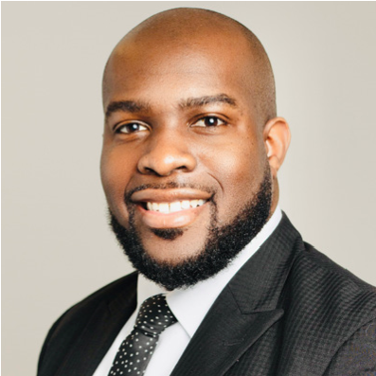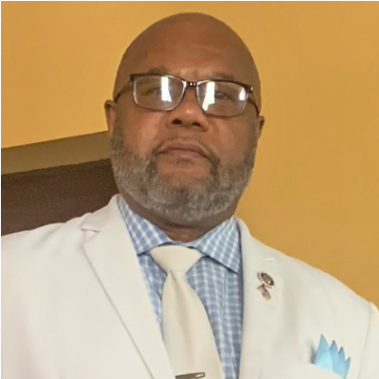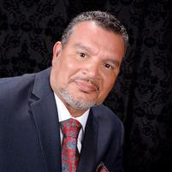

Bro. Sanford Irvin,

Topic-A

Tues. 10AM

Woodburn First Baptist Church

Woodburn, KY

Rev. Ronald Kendrick,

Expository Period

Tues. 1:30 PM

Rev. Irvin Cushenberry,

Topic-B

Tues. 1:30 PM

Ministers, Deacons and Laymen League

Auxiliary to the

First District Association of Baptists in Kentucky

Rev. Thomas Jones President

August 26, 2024

Dear Pastors, Associate Ministers, Deacons and Laymen:

Greetings! “In the name of our Lord and Savior Jesus Christ!” The time has come again for our 60th

Annual Session which will be held September 17, 2024. Registration will be from 9:00–9:45 AM at Durrett

Avenue Baptist Church, Hopkinsville, Kentucky. The host pastor is The Rev. Johnny Deeds.

We are looking forward to a spirit-filled event, as we come together to hear from the Lord through

President Rev. Thomas Jones who will give his address.

Enclosed with this letter is a Church Registration Form. The Church Representation is $75.00. The

(

M.D.L.L.) would appreciate your support.

May God Bless You until we gather for the 60th Annual (M.D.L.L.) Session!

Yours in Christ,

Rev. Thomas Jones, President

Ministers, Deacons and Laymen League

Auxiliary to the

First District Association of Baptists in Kentucky

60

th Annual Session

Church Registration Form

Church Representation $75.00

Each Man Attending $10.00

Church Name:__________________________________________________________________

Address: ______________________________________________________________________

Pastor: ________________________________________________________________________

Chairman of Deacons: ____________________________________________________________

Address & Phone#: ______________________________________________________________

NAME

AMOUNT

1.

________________________________________________________________________

2.

________________________________________________________________________

3.

________________________________________________________________________

4.

________________________________________________________________________

5.

________________________________________________________________________

6.

________________________________________________________________________

7.

________________________________________________________________________

8.

________________________________________________________________________

9.

________________________________________________________________________

10.

________________________________________________________________________

**TOTAL REGISTRATION $ ____________**

**SUBMIT PAYMENT TO:**

**MDLL**

**P.O. BOX 2091**

**HOPKINSVILLE, KY 42241**

**POC: CLAVEL MOSELEY**

**270-498-5619**

**EMAIL: CLAVELMOSELEY@YAHOO.COM**